Smart Utility Consumption System

# 🟢 **Overview**

The Electricity Consumption Management System is designed to store, manage, and analyze customer electricity usage data. The system focuses on organizing customer information, billing records, payments, and energy consumption details. It provides an easy way for electricity companies to monitor usage trends, detect high consumption customers, and support efficient resource management.

The project also applies normalization to the database to reduce redundancy and improve data consistency. Moreover, different queries and reports will be implemented to generate

# Database Design

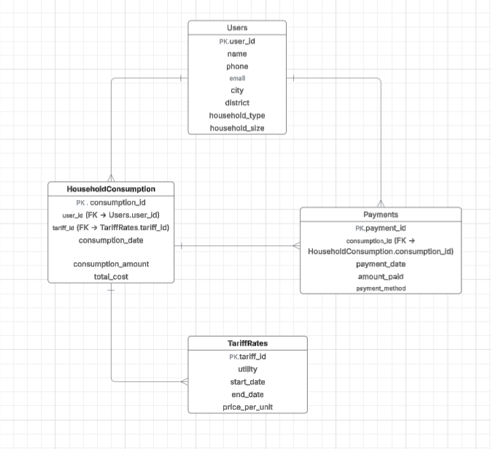

The figure shows the initial Entity-Relationship Diagram (ERD)

-**Main Entities and Relationships:**-

* **Users:** stores personal and household information such as name, contact details, household type, and size.
* **HouseholdConsumption:** records utility consumption for each user, including date, type, amount, and total cost.
* **TariffRates:** defines utility tariffs within a specific period, including start date, end date, and price per unit.
* **Payments:** stores user payment details for consumption, including date, amount, status, and payment method.

# Data Creation

After creating the database using SQL, we employed the **Faker** library in Python to generate synthetic data for populating it.  
The generated dataset covers: user information (such as name, email, and phone number), tariff rates, household consumption, and payments.  
The **total consumption cost** was directly derived from the unit price in the **TariffRates** table to ensure logical and consistent calculations.  
Moreover, payment amounts were restricted so that they never exceeded the total cost, thereby simulating realistic payment scenarios.  
This step was essential for testing the database design and verifying the integrity of relationships between tables before inserting real-world data

# SQL Analysis

SQL queries were used to extract meaningful insights from the database. More than 10 queries were implemented to answer real business questions, including:

* Identifying the top 10 highest consumers and the bottom 10 lowest consumers.
* Calculating total consumption per city and per utility.
* Analyzing monthly consumption trends by utility.
* Finding users with outstanding payments.
* Computing average consumption per household type and per household size.
* Calculating average payment per user and per payment method.
* Determining the month with the highest total cost per utility.

These queries helped validate the database design and provided initial insights before performing Python analysis and visualization.

# . Python Analysis

• **Data Loading & Cleaning:**  
Data from SQL Server tables (Users, TariffRates, HouseholdConsumption, Payments) were loaded using pandas and pyodbc. Date columns were converted to datetime. Missing payment values were replaced with zeros for accurate calculations.

• **Consumption Analysis:**

* Monthly consumption trends by utility to identify peak usage months.
* Average consumption by household size to study the relationship between family size and usage.
* Top 10 highest consumers and very low consumers for monitoring purposes.
* Average consumption by household type to detect usage patterns.

• **Payment Analysis:**

* Comparison of payments to total cost to calculate remaining balances.
* Identification of users with outstanding balances.
* Average payment per method to understand preferred payment options.
* Average unit cost per utility to compare costs across electricity, water, and gas.

• **Visualization:**  
Charts and graphs using matplotlib were created to visually present trends, top consumers, and payment patterns.

# Excel report

We use excel sheets we generated from python

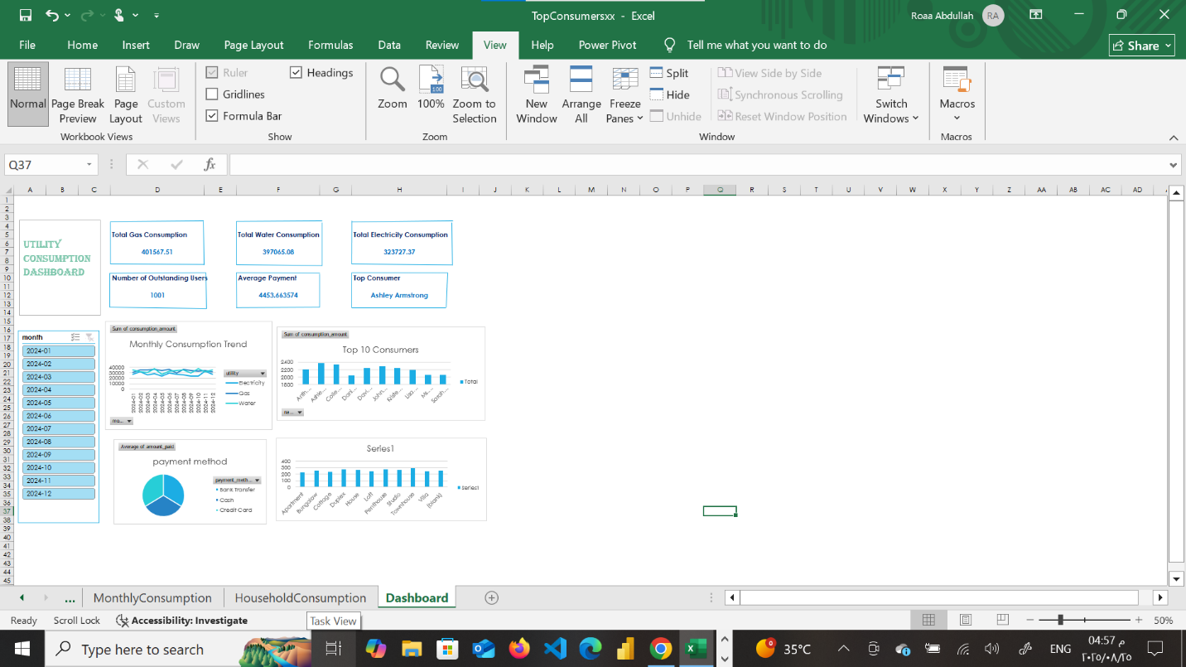

# Power BI

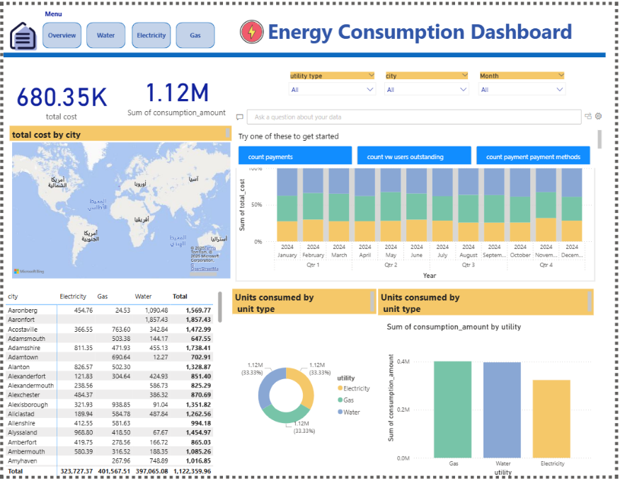  
The overview page displays total cost and total consumption , a map showing the total cost for cities, the total cost of each utility each month, a matrix showing each city's consumption of each utility and column chart that shows unit consumed by unit type .

Each page displays details for each utility like total cost , average unit cost , units consumed ….

